*Overview*

Hot and cold tumor are crucial in assessing the efficacy of existing cancer immunotherapies. A hot tumor is rich in tumor immune microenvironment (TME),

PD-L1 overexpression, genomic instability. Example of hot tumors include melanoma and lung cancer. In contrast, non-T- cell inflamed cancers, such as Triple Negative Breast Cancer (TNBC), prostate or pancreas cancers fall into the category of “cold tumors”. Simultaneously, tumor-associated macrophages (TAMs), T/B regulatory cells (T/Bregs), myeloid-derived suppressor cells (MDSCs) have been identified as contributor to the formation of a specific TME in “cold tumors”. Factors affecting tumor virulence include immune checkpoints (PD-1, PD-L1, CTL4, TIM-3, and LAG-3), tumor infiltrating lymphocytes (TIL), tertiary lymphoid tissue (TLS), microsatellite status (MSI), tumor mutational burden (TMB) and gene mutations (for ex.TP53, BRCA1).

Immune checkpoint inhibitors (ICIs) have shown success in improving the survival of cancer patient. ICI-mediated antitumor responses depend on the infiltration of T cells that identify and eliminate cancer cells. Therefore, ICIs are less efficacious in “cold tumors” which are characterized by the lack of T-cell infiltration.

*Specific Aims*

The aims of this project are to analyze the current landscape of strategies designed in “warming up” cold tumors to immune checkpoint inhibitors (ICIs); to introduce an innovative approach utilizing nanoparticles, viral vectors, or polymeric particles as potential solutions.

**Research Strategy**

1. *Significance*

According to the National Cancer Institute, in 2020, cancer-related healthcare expenses in the U.S. reached $208.9 billion. Since their peak in 1991, there has been a 33% decline in the rates of most common cancers, including lung, colorectal, breast and prostates, The trend has been attributed to a combination of factors, such as reduced smoking rates, advanced in therapies like ICIs, and the development of improved diagnostic and prognostic biomarkers. Nonetheless, cancer incidence rates have increased in breast, uterine, melanoma and prostate cancers [1].

In last 10 years, the FDA has approved an increasing number of Immune Checkpoint Inhibitors (ICIs) following successful clinical trials. These treatments have significantly enhanced long-term survival rates for metastatic patients and prolong progression-free survival for those in early stages of the disease. Cancer cell can escape detection and destruction by activating different molecules, such as PD1 or CTLA-4 on the surface of the T cells, inhibiting their activity. ICIs work by blocking the interaction between checkpoint molecules and their ligands found on the surface of the cancer cells, allowing T cells to remain activated. However, cold tumors are characterized by a deficiency in T cells, and in the absence of T cells, there are no checkpoint inhibitors to activate.

Tumor-associated macrophages TAMS, constitutes a significant source of tumor immunosuppression, and targeting TAMS, represents a promising strategy to transform cold tumor into hot tumor. TAMs can reduce T cells infiltration within the TME by promoting angiogenesis through factors like colony-stimulating factor 1 (CSF-1), VEGF and MMP9. Tumor cells can release CSF1, which interacts on monocytes or macrophages, inducing recruitment and differentiation of TAMs.

**Figure 1**: Mechanisms characterizing hot tumor vs. cold tumor.

Colony-Stimulating Factor-1 Receptor (CSF1R) and its binding molecule CSF1are prevalently observed in many cancers, including breast, prostate, pancreas, renal and ovary cancers. The inhibition of the CSF-1/CSF1R axis has demonstrated significant impact on the recruitment, and transformation of M2-like TAMs, showcasing potential therapeutic effects that could be contingent upon specific TME and cancer subtype.

In various preclinical models, such as mouse models of glioblastoma (GBM) and malignant meningiomas, blocking CSF1 has shown promise in `reeducation` of M2-like TAMs towards an antitumoral M1-like phenotype, leading to tumor reduction; additionally, encouraging preliminary antitumor activity were observed in GBM, and NSCLC. In recent years, a variety of small-molecule CSF1R inhibitors have been proposed and entered clinical trials. Nevertheless, despite the initial encouraging breakthrough in the management of TGCT, a non-malignant tumor, the translation of such therapies into effective monotherapies for malignant solid tumors has often been disappointing.

CSF1 inhibition has rarely led to tumor regression. As combinatorial therapy, the outcomes were more encouraging: combining CSF1R inhibitor (PLX3397) with checkpoint inhibitors like PD-1 or CTLA-4 antibodies reduced tumor progression by more than 90%. However, most of the clinical trials were stopped due to observed severe adverse events. Similarly, combining CSF-1/CSF1R inhibitors with conventional treatments like chemotherapy, radiotherapy or targeted therapies have yielded mixed results. While preclinical studies have shown prolonged survival rates, clinical responses in certain cancers, such as metastatic breast cancer, have remained modest with only a 16% Objective response rate (ORR) observed in a phase II study.

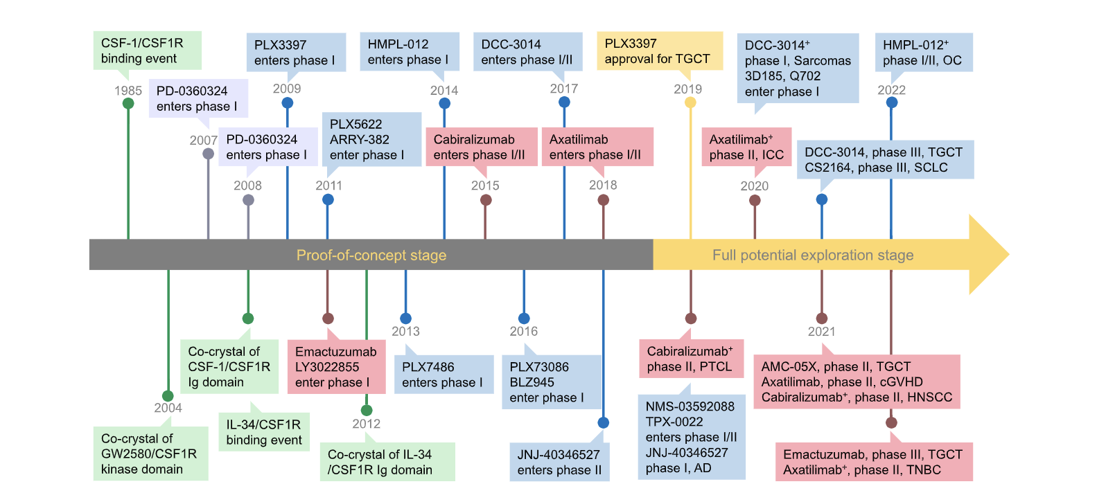

**Figure 2:** CSF1R inhibitor timeline

1. *Innovation*

The Poly (ADP-ribose) polymerase (PARP) family has many crucial functions in cellular processes, including the regulation of transcription, apoptosis and promotes the repair of DNA. PARP inhibitor (PARPi) have been shown to be efficient against homologous recombination repair of cancer cells. By inhibiting PARP, a PARPi-derived drug could induce DNA damage accumulation, leading to lethality in cancer cells with defects in DNA repair mechanisms. Additionally, PARPi can upregulate PD-L1 expression and PD-L1 upregulation can contribute to an inflammatory feedback loop that enhances T cell infiltration.

Research has shown that PARPi can foster the recruitment and activation of CD4+ and CD8+ T cells via neoantigen generation and the release of cytokines and chemokines like INF- $γ$, CCL5, and CXCL10 [22, 23].

In cancer therapy, inhibiting CSF-1R has been shown to augment the efficacy of PARP inhibitors (PARPi). This inhibition disrupts the recruitment and activity of tumor-associated macrophages (TAMs), which are often immunosuppressive and promote tumor progression. By targeting CSF-1R, the presence of these TAMs in the tumor microenvironment can be diminished.

Research indicates that the combination of CSF-1R inhibition with PARP inhibitors can lead to synergistic effects, effectively restraining tumor growth and improving treatment outcomes. This combination therapy not only bolsters the anti-tumor immune response but also increases tumor sensitivity to PARP inhibition.

Combination therapies, such as PD-L1 or PD-1 inhibitors with anti-CTLA4 which enhance priming and activation of antigen-specific T-cells, are examples of strategies being explored in this context. Employing a combination of these inhibitors alongside TAMs inhibitors, within the drug tolerance limits, could offer synergistic benefits.

We intend to enhance the therapeutic potential of exosomes derived from iPSC-MSC by utilizing them as carriers for PARPi cargo. These exosomes will be further modified by conjugating them with a CSF-1R inhibitor to target tumor-associated macrophages (TAMs) and cancer cells. To increase specificity and minimize off-target effects, we propose surface modifications of the exosomes derived from MSCs. This modification will involve conjugating the exosome surface with CSF1R, as well as markers specific to TAMs, such as CD68 or CD163, and markers specific to various cancer cell types. For instance, epithelial-derived tumors may be targeted using EpCam, breast cancer using HER2, or ovarian cancer using CA125.

1. *Research Plan*

*Facts And Figures Cancer Related References*

[1] American Cancer Society – Cancer Facts & Figures 2024

[2] Asher Mullard “22 FDA approvals” nature reviews drug discovery

*Significance References*

1. **Turning cold tumors into hot tumors by improving T cell infiltration**

Yuan-Tong Liu, Zhi-Jun Sun doi: 10.7150/thno.58390

1. **Turning cold tumors hot: form molecular mechanisms to clinical applications**

Jiahui Zang et al. Trend in Immunology

1. **Strategies for Heating Up Cold Tumors to Boost Immunotherapies**

Danie Zabranksy et al. Annual Review of Cancer Biology

1. with chemotherapies to improve patient outcomes.

### [Hot and cold tumors: Immunological features and the therapeutic strategies](https://onlinelibrary.wiley.com/doi/abs/10.1002/mco2.343)

L Wang, H Geng, Y Liu, L Liu, Y Chen, F Wu, Z Liu

<https://doi.org/10.1002/mco2.343>

1. **Combining in site vaccination and immunogenic apoptosis to treat cancer.**

Arman Lamai, Mehdi Shalgolzari – Future Medecine – Immunotherapy – Vol.15, Issue 5

1. **Dendritic cells and natural killer cells: The road to a successful oncolytic virotherapy**

Matin Ghasemi et al. Frontiers in Immunology

1. **Pouring Petrol on the flames: Using oncolytic virotherapies to enhance tumor immunogenicity.**

Alicia Teijeira Crespo et al. Wiley Library, Immunology

1. **Unlocking the potential of antibody-drug conjugates for cancer therapy**

Joshua Z. Drago et al. doi:10.1038/s41571-021-00470-8.

1. **Tumor Targeting of a Sting Antagonist with an Antibody-Drug Conjugate Elicits Potent Anti-Tumor Immune Responses.**
2. **Antibody-Drug Conjugates: A Review of Approved Drugs and Their Clinical Level of Evidence**

Review by Pooja Gogi et al. Cancers

1. **The Evolution of Antibody-Drug Conjugates: A Positive Inflexion Point**

Anthony W. Tolcher - ASCO Educational Book

*Research Previous Approaches*

1. **Igniting Hope for Tumor Immunotherapy: Promoting the “Hot and Cold” Tumor Transition**

Chen Wei et al., DOI: [10.1177/11795549221120708](https://doi.org/10.1177/11795549221120708)

Sage Journal: Clinical Medicine Insights: Oncology Volume 16.

1. **Advancing cellular immunotherapy with macrophages**

Alok K. Mishra et al. DOI: <https://doi.org/10.1016/j.lfs.2023.121857>

1. **Targeting tumor-associated macrophages in hepatocellular carcinoma: biology, strategy, and immunotherapy**

Hongyu Zheng et al. Cell Death Discovery (2023(9: 65) Nature

Doi: https://doi.org/10.1038/s41420-023-01356-7

1. **CSF1R inhibitors are emerging immunotherapeutic drugs for cancer treatment**

Jiachen Wen et al., DOI: [10.1016/j.ejmech.2022.114884](https://doi.org/10.1016/j.ejmech.2022.114884)

Elsevier - European Journal of Medicinal Chemistry

1. **Targeting tumor-associated macrophages for successful immunotherapy of ovarian carcinoma**

Iva Truxova et al., DOI: [10.1136/jitc-2022-005968](https://doi.org/10.1136%2Fjitc-2022-005968)

Journal for Immunotherapy 2023

1. **Sophisticated genetically engineered macrophages, CAR-Macs, in hitting the bull’s eye for solid cancer immunotherapy.**

Nese Unver, DOI: https://doi.org/10.1007/s10238-023-01106-0

Clinical and Experimental Medicine 2023

1. **Engineering extracellular vesicles derived from macrophages for tumor therapy.**

Ying Yan et al., DOI: [10.1039/D2MA00961G](https://doi.org/10.1039/D2MA00961G)

Royal Society of Chemistry

1. **Recent advances in macrophage-derived exosomes as delivery vehicles**

Shumin Wang et al. DOI:  <https://doi.org/10.26599/NTM.2022.9130013>

1. **Therapeutic Targeting of DNA Damage Repair in the Era of Precision Oncology and Immune Checkpoint Inhibitors**

Curis Clark et al., DOI: <https://doi.org/10.36401/JIPO-22-15>

1. **Dual antitumor immunomodulatory effects of PARP inhibitor on the tumor**

**microenvironment: A counterbalance between anti-tumor and pro-tumor**

Xiao-Fang Yi et al., DOI: 10.1016/j.biopha.2023.114770

ELSEVIER - Biomedicine & Pharmacotherapy 163

1. **The evolving landscape of biomarkers for checkpoint inhibitor immunotherapy.**

Havel JJ, Chowell D, Chan TA (2019), Nat Rev Cancer 19(3):133–150. <https://doi.org/10.1038/s41568-019-0116-x>

1. **Beyond DNA repair, the immunological role of PARP-1 and its siblings.**

Rosado MM, Bennici E, Novelli F, Pioli C (2013) Immunology 139(4):428–437. <https://doi.org/10.1111/imm.12099>